Lab #7: Implementing Mux Circuits and

Counters Using SimUAid
ECE3441-19134 -FA2025
Anaya Scott

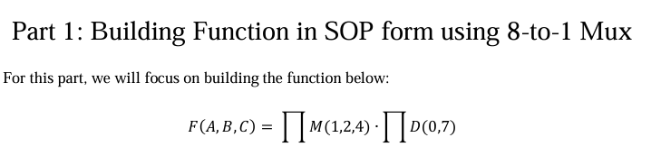
Questions:
- In your own words, define what a MUX is and how it can be used in digital logic design.
  - Is when a group of data inputs and a control input are used to select one of the data inputs and connect it to the output to create a logic 0 or 1 from a desired truth table.
- Design a circuit that implements the function above by using a MUX. Include a figure
with a schematic of your design.
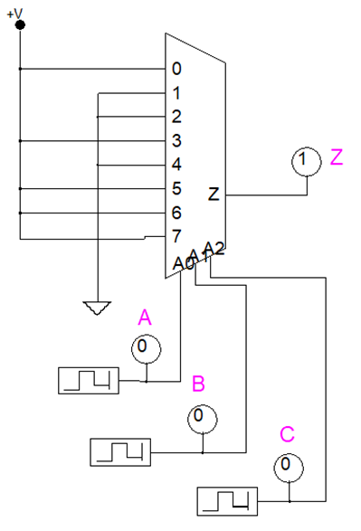
- How would you implement a function that has 4 variables with 3-variable MUXes?
  - To implement the 4 variable functions using a 3 variable MUX, you would have to fix one variable and use it to select between 2 8-to-1 MUX. This is for when one MUX is a fixed variable of 0 and the other would be a fixed variable of1, then they are connected to outputs to a 2-to-1 MUX. That is then controlled by the fixed variable.
- How many unique functions could you implement with a 5-variable MUX?
  - 5 variable functions generally will be a 32-to-1, which is implemented because of the 2^32 unique Boolean functions. This is because each input combination from the 5 variables can be assigned to 0 or 1 individually.
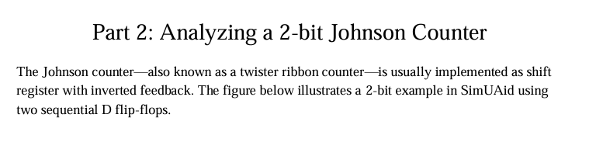
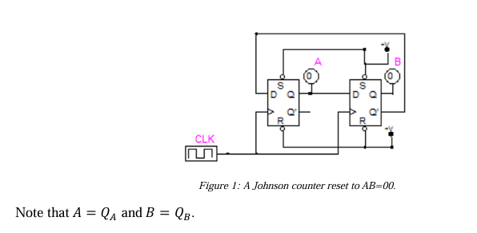
Questions:
- Find the equations for 𝐴+ and 𝐵+ as a function of 𝐴 and 𝐵.
  - 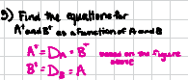
- Make a transition table using your equations for 𝐴+ and 𝐵+.
  - 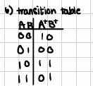
- What is the period of this machine? Are there any unused states?
  - This cycle only has 4 states, 00,10,11,01, meaning that there are no unused states in this sequence.
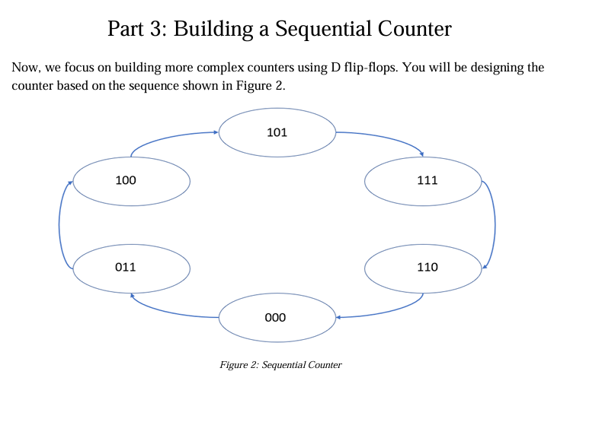
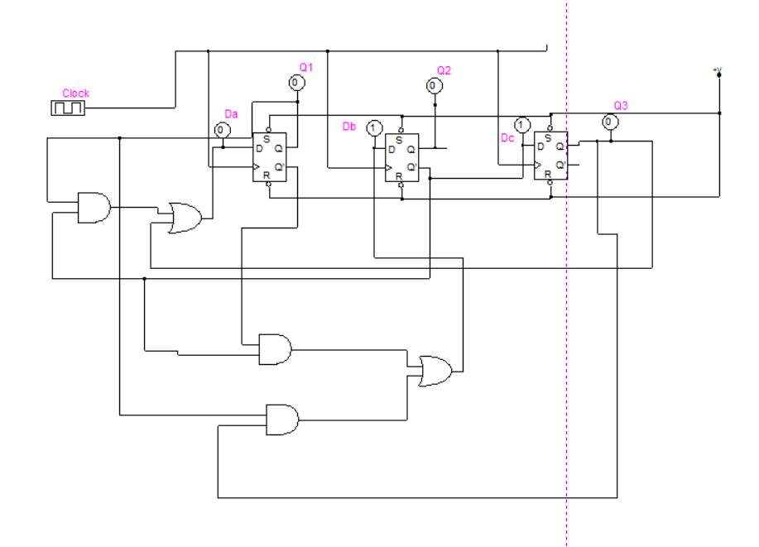
Figure 3: The schematics of the D flip flop expression from question 12.
Questions:
- As you can see from Figure 2, each stage is made up of 3-bit values. How many states can the machine start in?
  - Since the machine has 3 flip flops this means 2^3 = 8 possible states. But theoretically there are only 6 states that can be used in the sequence, as two states wouldn’t satisfy the conditions of the flip flop.
- Make a transition table for your sequential counter.
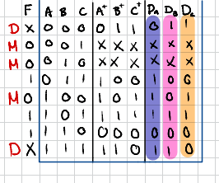
- Which states are not used? Using your transition table, determine what happens if the counter starts in these states by accident.
  - The unused states in the counter would be 001 and 010. If the counter starts at unused state, then the counter would start to self-correct itself.
- If unused states accidentally create a secondary loop when they are treated as don’t-cares, what can be done to fix it?
  - Note that the machine will get stuck in a secondary loop if the unused states are treated like don’t cares. To fix this it would be to force the counter to the main cycle by powering up the PRE/CLR signal.
- Provide next-state equations for your design.
  - 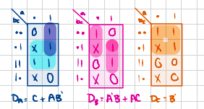
13. What are the reasons for the D flip-flop having the inputs labeled as S and R? Why must we keep them high? Note: The S and R inputs should not be mistaken for the SR latch or
SR flip-flop.
Note that the S-R inputs on a D flip flop represent the Set and Reset. They will override the clock making the flip flop output to a logic 1 or 0. They need to be kept on high aka inactive to make the cycle a normal synchronous pattern. If not, it can cause unpredictable behavior for the flip flop and get stuck in a secondary loop.

Part 4: Counter Circuit Hardware Implementation
14. Explain in your own words what “button bouncing” is and what it can do to sequential
circuits.
Button bouncing is when a button is pressed or released making multiple breaks before allowing the cycle to settle to the next state. This creates an unpredictable pattern in your circuit.
15. Did you demo to a TA, or did you take a video? Describe who observed your demo or
leave your link here.
I demonstrated my working circuit to the available TA, Darwhich Falou on 11/17/25.

Conclusion
In this lab, I was able to understand how to implement logic functions using a MUX and analyze Johnson and sequential counters using a D flip flop, which addresses practical hardware issues like button debouncing. This lab emphasized a meticulous planning in state cycling design and verifying functionality of the simulation and hardware.

